U-App for Lasalle

Mobile Application & Admin Suites

2023-12-23_v3

**Table of Content**

U-App for Universities 3

Overall Technology 3

● Mobile Application deployable for Android and iOS phones 3

● Website/Web Server for the Admin Suites 4

o Frameworks and Software 4

o Server 5

Architecture Design 6

Privacy & Security 6

Scope & Questions to Lasalle 7

Data Flow Diagrams 9

Master Admin DFD 9

School Admin DFD 10

# 

# 

# U-App for Universities

**Introduction**

U-App is a mobile app for educational institutions to improve the mental health of their students.

Through U-App mental health related content is made to available to students while engaging all relevant stakeholders, such as students, institutions, teachers, counselors and parents via one system.

The Mobile App is administered through a web-based backend designated school staff.

Each user group is engaged in a specific way

* **Students:** get access to mental-health counselors and age-adequate videos (“vidz”) and write ups.
* **Parents:** parent videos and write ups – not visible to students.
* **Teachers & Counsellors**: resources for professional content
* **School Admin:** can see all- except confidential counselling records
* **Master Admin** can see all – except confidential counselling records

# Overall Technology

## Mobile Application deployable for Android and iOS phones

* + Programing Languages used
    - Typescript
  + Frameworks and Softwares used in Development
    - React-Native
      * is an open-source UI software framework created by Meta Platforms, Inc. It is used to develop applications for Android, Android TV, iOS, macOS, tvOS, Web, Windows and UWP by enabling developers to use the React framework along with native platform capabilities.
    - Expo
      * an open-source framework for building React Native apps with consolidated logic for both iOS and Android
    - Docker
      * is a set of platform as a service products that use OS-level virtualization to deliver software in packages called containers.
  + Compatible Mobile OS
    - Android
      * Must be Android 11 or above
    - Ios
      * Only tested on the latest Ios version

## Website/Web Server for the Admin Suites

* + Programing Languages used
    - HTML5
    - PHP
    - Javascript
    - CSS

## Frameworks and Software

* + - Laravel
      * Laravel is a free and open-source PHP web framework, created by Taylor Otwell and intended for the development of web applications following the model–view–controller architectural pattern and based on Symfony.
    - Docker
      * Docker is a set of platform as a service products that use OS-level virtualization to deliver software in packages called containers.
    - Bootstrap
      * Bootstrap is a free and open-source CSS framework directed at responsive, mobile-first front-end web development. It contains HTML, CSS and JavaScript-based design templates for typography, forms, buttons, navigation, and other interface components.

## Server

* + Main Domain is currently in **Apache** but we intend to use **Nginx** for future Production
  + EC2
* Database
  + - mysql
    - AWS RDS

## Architecture Design

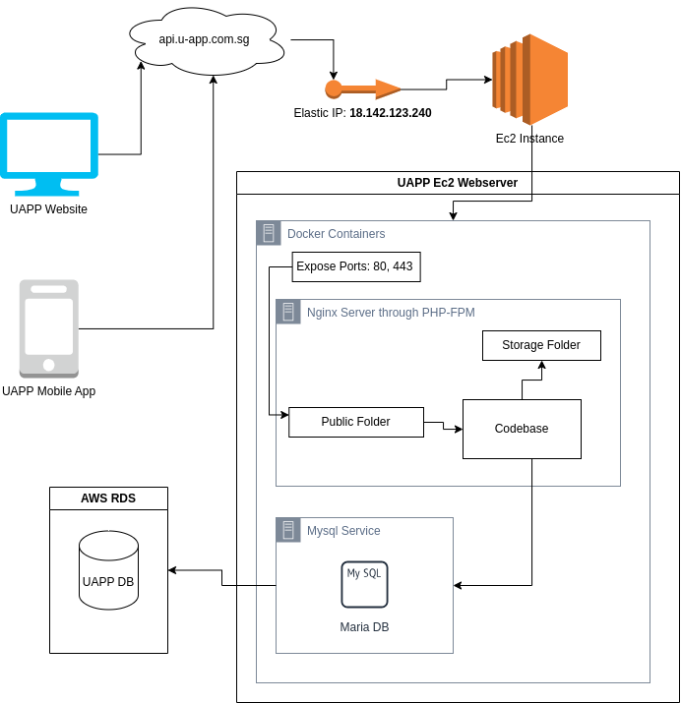

## Privacy & Security

· The webserver is always updated to the latest version.

· Automatically generates a token for each active user session managed by the application. This token is used to verify that the authenticated user is the one actually making the requests to the application. User token authorisation.

· File uploads and Forms also contains a token that is verified by the application.

· Provides secure hashing for storing all user passwords.

· Access to the file directories from the server is prohibited.

· Databases and Web files are always backed up automatically by the server.

· SSL ( Secure Socket Layer ) certificates are also used to prevent data sent to the internet from being collected.

For more information see below..

# Scope & Questions to Lasalle

**Integration with existing solutions on Lasalle’s side**

* Is there an existing solution and database?
  + UAPP allows importing user data through the Admin Suites.
* If so, what are the specificities of it?
  + For now we expect a spreadsheet file with a specific format
* Is it open to import data from it?
  + For now we plan for the school admin, as the only staff who could import the data. No automatization in the current version, yet customised solution can be built.

**How is the current set-up securing data-security and privacy?**

* Which technology is used, which Databases, access etc.
  + For our U-App production environment, we leverage AWS RDS, a highly scalable and secure database accessible exclusively through the EC2 web server. It is meticulously managed by AWS's own security protocols and has its own monitoring system. As our preferred database management system, we utilize MySQL due to its optimal compatibility with the Laravel framework. This choice enhances security by mitigating threats that may exploit programming issues.

**Who will be operating the U-App/Lasalle System**

* Please explain the personnel involved, so that we can cater to them.
  + We currently assume: School Admin and Counsellors are the users needed to operate the U-app. School admin is the highest user type which is mostly responsible for creating or importing other user data. Counsellors manage and monitor the users activities. They also have capabilities to add posts(videos, shorts, audio) reports or evaluations on students and teachers.

**What are the requirements for staff and counsellors and school admin in terms of access and data-privacy**

* U-App approach, please see comments on our our current architecture.
  + As we employ Laravel for both the website and web server, the framework utilizes the Form Classes Token Method, commonly known as CSRF token. This method ensures that each request originates from the application itself, preventing potential cross-site scripting (XSS) attacks by third parties. The sole conceivable way for a third party to access the application is through the theft of their access credentials. AWS services have undergone rigorous testing for security and scalability, minimizing the likelihood of data leaks and hacking incidents..
  + Access credentials are automatically generated during the user data creation process and are transmitted via email. Users will be prompted to change their password upon their initial login.
  + All user API requests (which are used when the mobile app get data from the web server) necessitate the inclusion of the correct access token, a unique identifier generated during each user login. This access token is consistently and uniquely created using Laravel's proprietary method.
  + All sensitive data like passwords are encrypted using AES-256-CBC (Advanced Encryption Standard with a 256-bit key in Cipher Block Chaining mode) . This is considered very secure and is widely used for encrypting sensitive information. As of 2023, there are no practical or known cryptographic attacks that can break the encryption provided by AES-256 when implemented correctly.

**Which data is required in a School-Admin Dashboard?**

* Each usertype has different user data required. Below are the fields U-App covers as of now.
  + School Admin
    - name
    - email
  + Counselors
    - name
    - email
    - gender
    - address
    - date of birth
  + Teachers
    - name
    - department
    - email
    - date of birth
    - gender
    - address(optional)
    - mobile phone number
    - department(optional)
    - specialty(optional)
  + Students
    - name
    - department
    - email
    - date of birth
    - gender
    - address(optional)
    - mobile phone number
    - course
    - school level
  + Guardians
    - name
    - email
    - gender
    - address
    - date of birth
  + Class Details
    - Class name
    - Schedule
    - Student Grades

# Data Flow Diagrams

## Master Admin DFD

Last Update: Dec. 22, 2023

## School Admin DFD

Last Update: Dec. 22, 2023

# 

# Sample Data

**School Admin**

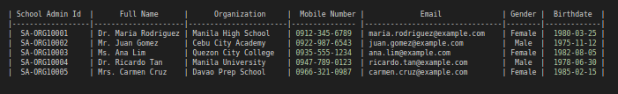

**Students**

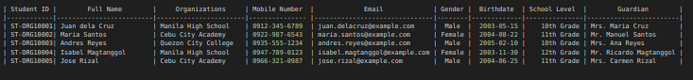

**Teachers**

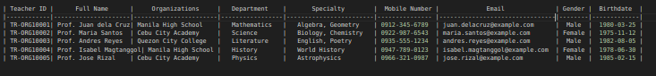

**Counselors**

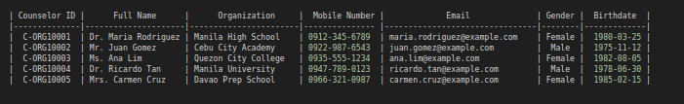

**Guardians**

